COM535 Cyber Security Lab

Instructions

- Login to https://www.hacksplaining.com/lessons

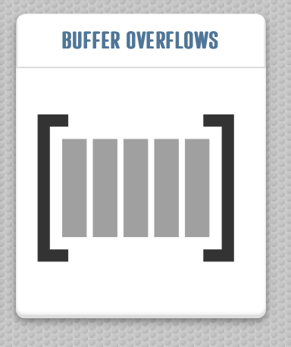 | 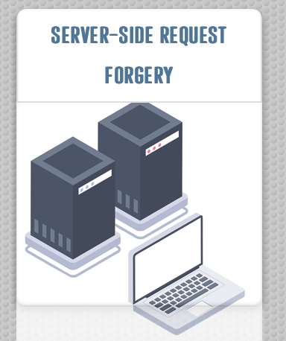

- Complete the two vulnerability lessons which are Buffer Overflows and Server-Side Request Forgery.

Network Security

- Complete Passive Reconnaissance https://tryhackme.com/jr/passiverecon

Help video: https://youtu.be/L0o3GG_hpkw

- Complete Active Reconnaissance https://tryhackme.com/jr/activerecon

Help video: https://youtu.be/A0J6oVB5CaE

- Complete NMAP Live Host Discovery https://tryhackme.com/jr/nmap01

Help video: https://youtu.be/19F0QostRhU

